Order Of Service

Singing: Psalm 119b—CW page 110

Reading: Psalm 54

Opening Hymn: TLH 23

Reading: Acts 5:12-16

Request Hymn: CW Supplement 754

Reading: John 12:36b-43

Sermon Hymn: TLH 656

Sermon Text: Song Of Solomon 8:5

Wilderness Exodus # 2

Prayer

The Apostles’ Creed, TLH page 12

Holy Communion

The Lord's Prayer

The Blessing

Closing Hymn: TLH 29

* * * * * * * * * * *

Bible Study: Lambs: Corn
Sheep: Romans 4:1-12
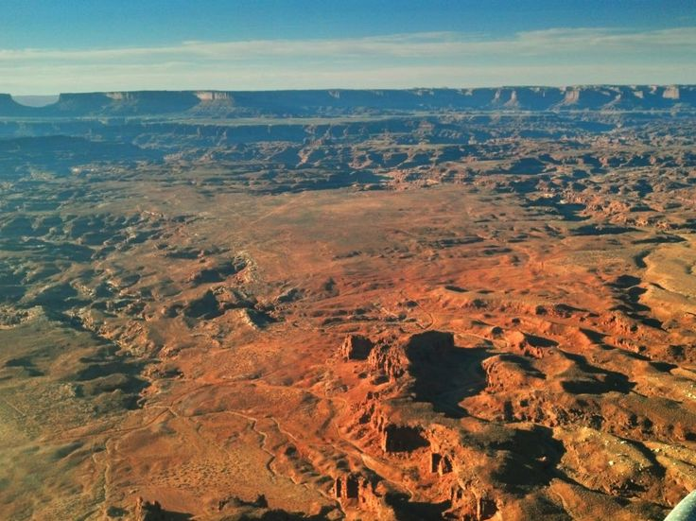

Great & Terrible Wilderness

Water
Of
Life

10 September 2017

W A T E R O F L I F E

Independent Christian Church—Conservative Lutheran Doctrine

Worship Service: 9:30 a.m. Bible Study: 10:45 a.m.

Larry Cooper, Pastor E-Mail address:
111 N. Ridge Road lcooper@wateroflife.cc
Coon Valley, WI 54623 Web Site:
Phone: (608) 452-2105 www.wateroflife.cc

* * * * * * * * * * * * * * * * * * * * * * * * * * *

Sermon Text: Song Of Solomon 8:5

Wilderness Exodus # 2

* * * * * * * * * * * * * * * * * * * * * * * * * * *

Song of Solomon 8:5 Who is this that cometh up from the wilderness, leaning upon her beloved? I raised thee up under the apple tree: there thy mother brought thee forth: there she brought thee forth that bare thee.

Wilderness Exodus # 1

Song of Solomon 3:6 Who is this that cometh out of the wilderness like pillars of smoke, perfumed with myrrh and frankincense, with all powders of the merchant?

Wilderness Exodus # 2

Song of Solomon 8:5 Who is this that cometh up from the wilderness, leaning upon her beloved? I raised thee up under the apple tree: there thy mother brought thee forth: there she brought thee forth that bare thee.

Under The Apple Tree

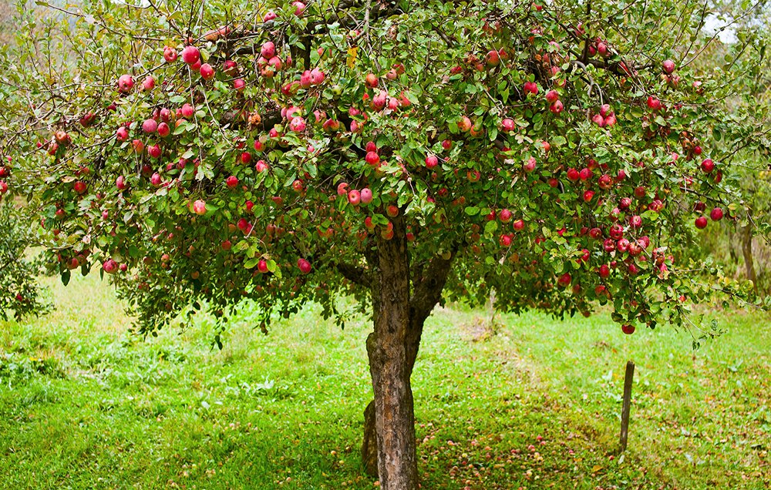

Song of Solomon 2:3 As the apple tree among the trees of the wood, so is my beloved among the sons. I sat down under his shadow with great delight, and his fruit was sweet to my taste.

